I look into the wiring diagram and my car.... it looks like 301A harness does not have the plate connector and job2 car do not have the BCMB at the back. Job2 car wire everything to the BCM at the front now.

The wire is there to the BCM (except CLN52 (WH-GN) which need to be add). Add the wire and pin to the C2280D connector and tap wire to the other (below).
The door plate is wire to (right hand side of kick panel where the fusebox is):
C2280D: pin 1: CLN52 and pin 27: RLN44
C2280G: pin 1: CLN53 and pin 14: CLN51
For the C2280D pin 1, the wire is not there in the harness so you will need to add the wire and pin into the harness.
You will need this pin to add to the header: 1924955-3 (I bought it from digikey)
https://www.te.com/en/product-1924955-3.html
Also need to buy 2 pigtail for the plate:
WPT-394 (around $30 each, need 2)

22 Gauge wire:
https://www.amazon.com/dp/B0CFJXMDT3?ref=cm_sw_r_cso_sms_apin_dp_XNQXPWK59N0BJGQWN4ER&ref_=cm_sw_r_cso_sms_apin_dp_XNQXPWK59N0BJGQWN4ER&social_share=cm_sw_r_cso_sms_apin_dp_XNQXPWK59N0BJGQWN4ER
After installing everything, you will need to enable it from Forscan to enable MyColor and the zone3
The APIM and BCM are the two modules that'll need to be programmed. The APIM is already fully programmed for ambient lighting; it just needs the option turned on for myColor. Reference: https://www.mustang7g.com/forums/threads/adding-ambient-lighting-onto-non-al-mustang.172384/

APIM - 7D0-01-02
Automatic Transmissions | xxxx​ | x4xx​ | xx--​
Manual Transmissions | xxxx​ | xCxx​ | xx--​

For Zone 3 (Sill Plate)
BCM - 726-37-02 | x7x4 | xxx4 | xx--

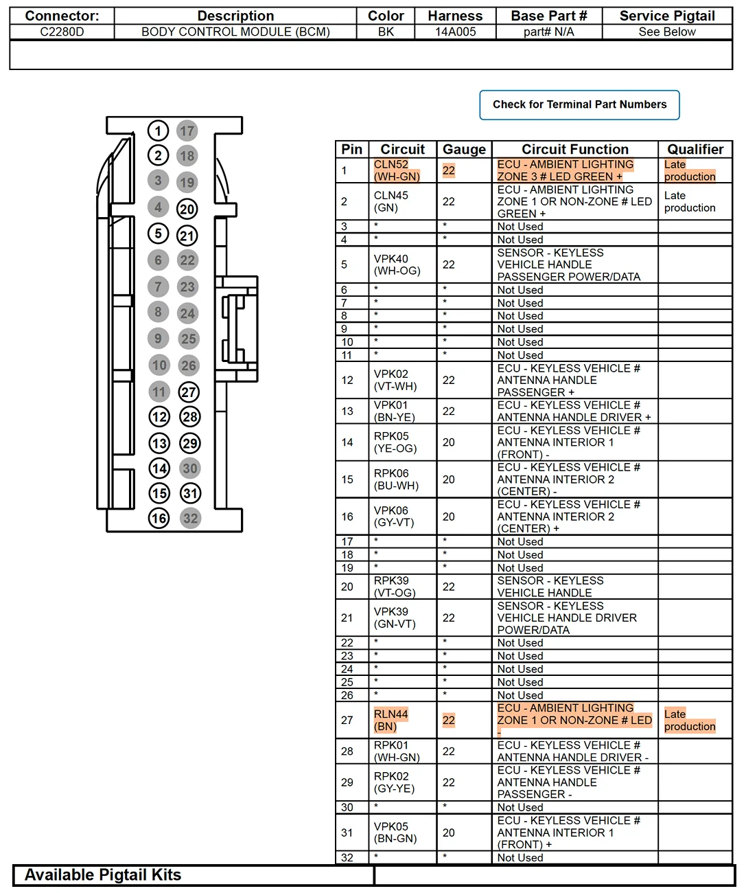

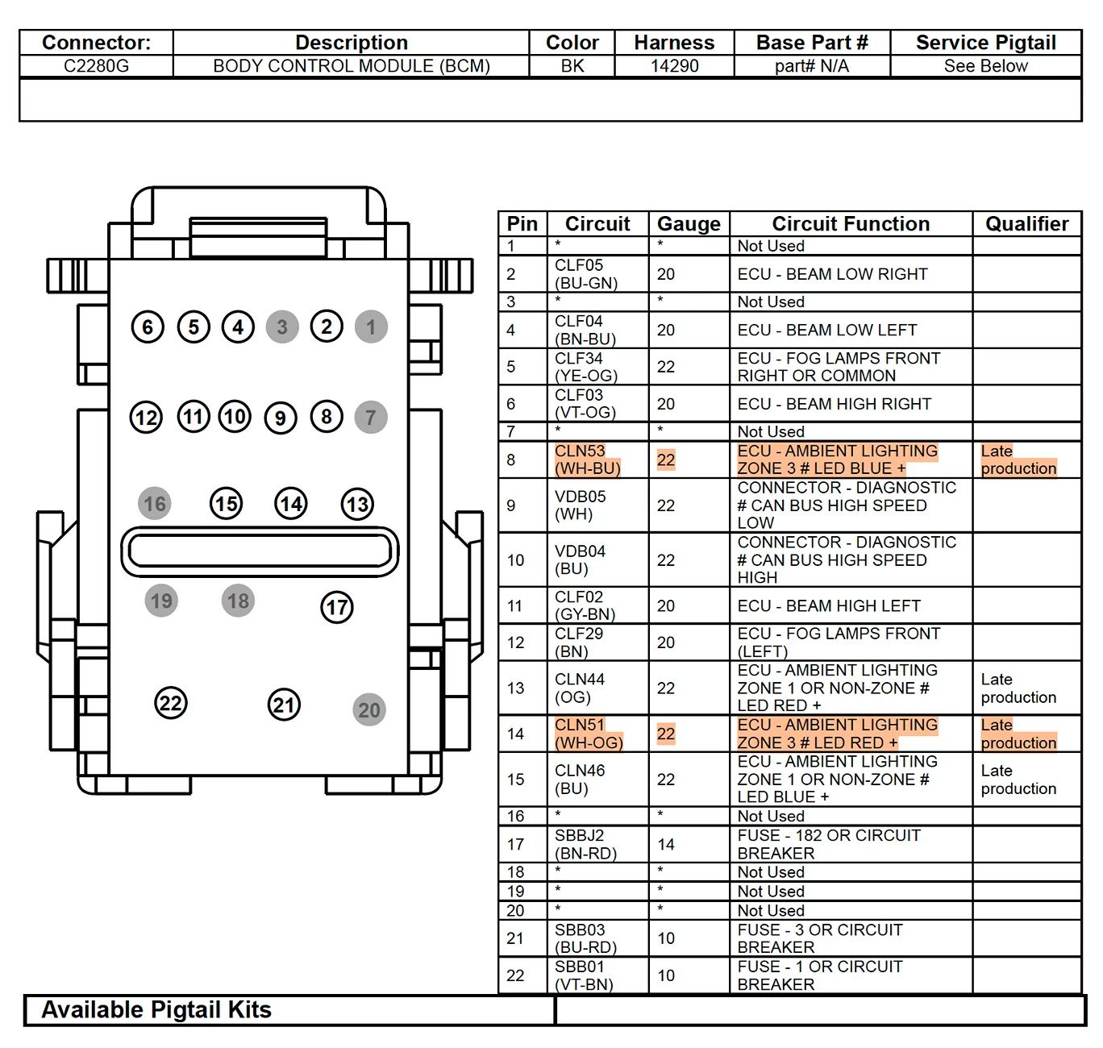

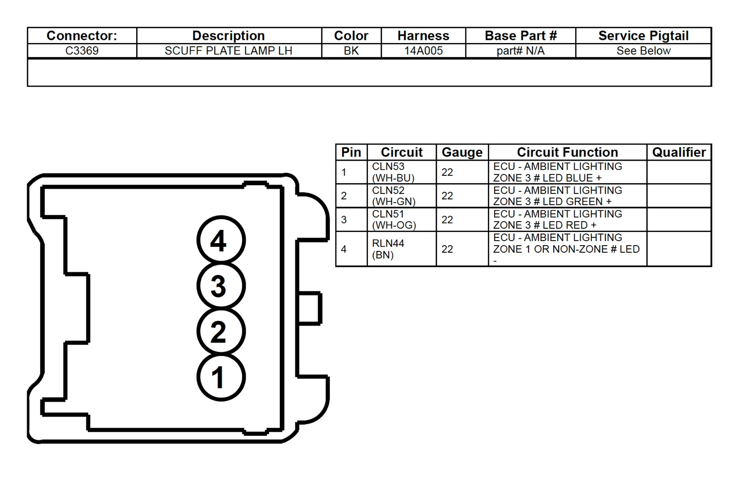

CLN53=White
CLN52=Red
CLN51=Yellow
RLN44=Black

